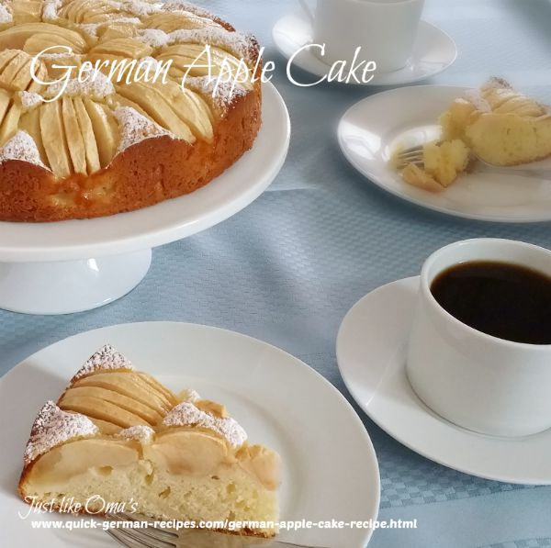

German Apple Cake Recipe
Ingredients:
- 3 - 5 apples
- 1/2 cup butter, room temperature
- 3/4 cup granulated sugar
- 2 eggs
- 1 tsp lemon juice
- 1 3/4 cup all-purpose flour
- 1 1/2 tsp baking powder
- 1/2 tsp salt
- 1/2 cup milk
- powdered sugar (icing sugar)
Instructions:
- Preheat oven to 350° F.
- Grease bottom and sides of a 10-inch springform pan.
- Peel, quarter, and core apples. Thinly slice each quarter several times without cutting all the way through. Do this just before you place them on cake. The apples "open" when they are baked.
- In a medium bowl, beat butter and sugar, eggs and lemon juice until creamy.
- Blend flour, baking powder, and salt. Stir into sugar mixture alternately with the milk.
- Spread batter in the pan. Arrange apple quarters as shown.
- Bake 50 to 55 minutes or until a wooden pick inserted in center comes out clean.
- Cool in pan on wire rack. Remove the cake from pan.
- Dust with powdered icing sugar just before serving. Put a tablespoon of powdered sugar into a small sieve. Gently strike the sieve with a spoon to sprinkle it evenly over cake.
Hints: Add 1/2 to 1 tsp almond flavoring instead of or as well as the lemon juice.

Bienenstich
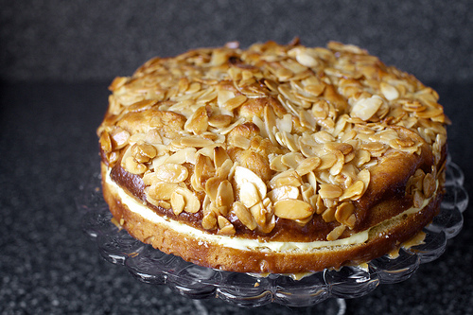
Cake
2 1/4 teaspoons (or 1 1/4-ounce package) instant yeast (not active dry)
3/4 cup whole milk, ideally at room temperature
1/4 cup granulated sugar
2 cups all-purpose flour
3/4 teaspoon table salt
2 large eggs, ideally at room temperature
4 tablespoons unsalted butter, at room temperature
Honey-Almond-Crunch Topping
6 tablespoons unsalted butter, cold is fine
1/3 cup granulated sugar
3 tablespoons honey
2 tablespoons heavy cream
1 1/2 cups (4 3/4 ounces) sliced almonds
Two pinches of sea salt
Pastry Cream Filling
1 cup whole milk
Seeds from 1/4 to 1/2 vanilla bean, 1 teaspoon pure vanilla extract or 1/4 teaspoon almond extract
3 large egg yolks
1/4 cup granulated sugar
3 tablespoons all-purpose flour or cornstarch [updated]
2 pinches sea salt
2 tablespoons unsalted butter, cold is fine
Make the cake: Combine all of the cake ingredients in a medium-sized mixing bowl, stirring till the mixture becomes cohesive, then stirring for two minutes more. In a stand mixer, you can mix this with the paddle attachment (no dough hook needed; batter is thin) at low-medium speed for 2 to 3 minutes. Scrape down sides, cover with plastic wrap and let rise in a draft-free place for 60 minutes, till it’s a little puffy. (It won’t fully double; this is fine.)
Butter a 9-inch round cake pan. Stir the batter a few times to deflate it slightly, then scrape it into the prepared pan and nudge it until it fills the bottom. Cover again with plastic wrap (don’t let it drape in and touch the top) and set aside for another 30 minutes.
Meanwhile, make the honey-almond-crunch topping: In a small or medium saucepan over medium heat, heat the butter, sugar, honey, cream and salt until the butter is melted. Bring to a simmer and let it boil for 3 to 5 minutes, until the mixture becomes a shade darker (it should go from a yellowish tone to a light beige), stirring frequently. Stir in the almonds. This mixture is going to get very thick. Set it aside to cool slightly.
Heat your oven to 350 degrees.
Once the cake has finished its second rise (again, it’s not going to rise a lot) use a small spoon to scoop out small amounts of the almond topping and distribute it over the top of the cake. It’s going to be a little pesky because it is firm, but even if it’s not perfectly evenly distributed, it will all smooth out in the oven.
Bake cake on a foil-lined tray to catch any caramel drips, for 20 to 25 minutes, until top is bronzed and toothpick inserted into the center comes out batter-free. (Caramel on it is fine, and should be tasted.) Transfer to a cooling rack and let it sit in the pan for 10 minutes. After 10 minutes, run a knife along the outside of the cake, making sure no places are stuck and invert the cake onto the cooling rack. Reverse it back onto another rack to finish cooling, replacing any almonds that fell off right back on top. They’ll merge back with the caramel as it cools.
Make pastry cream: Warm milk and vanilla bean scrapings (if using; if using an extract, don’t add yet) in a medium saucepan. Pour into a small bowl or cup, ideally with a spout. Set aside. Rinse saucepan with cool water, to rinse and cool; wipe to dry. Off the heat, whisk the yolks and sugar vigorously together for a minute, until pale and ribbony. Whisk in flour and salt until smooth. Drizzle in warm milk mixture, a spoonful at a time, whisking the whole time. Once you’ve added half of it, you can add the rest in a steadier stream, again whisking the whole time. Return the saucepan to the stove and cook on medium-high heat until it bubbles, then simmer for one to two minutes, more whisking the whole time. Off the heat, whisk in the butter and any extracts you may be using. Cool custard completely before using, a process that can be sped up in the fridge or whisking it over a bowl over ice water.
Finally, assemble the cake: Once both the cake and pastry cream are fully cooled, place the cake on a serving platter and divide it horizontally into two layers with a long, serrated knife. Spread pastry cream over bottom half. Place top half on pastry cream. Serve in wedges. Refrigerate any leftovers.

Authentic Black Forest Cake

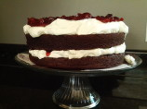

Ingredients

Cake
  - 1 2/3 cups all-purpose flour
  - 2/3 cup cocoa powder
  - 1 1/2 teaspoons baking soda
  - 1 teaspoon salt
  - 1/2 cup shortening
  - 1 1/2 cups sugar
  - 2 eggs
  - 1 teaspoon vanilla
  - 1 1/2 cups buttermilk

Filling
  - 1/2 cup cherry juice
  - 1/2 cup unsalted butter
  - 3 cups icing sugar
  - 1 pinch salt
  - 1/4 cup espresso
  - 1 1/2 lbs. fresh black cherries

Icing
  - 2 cups heavy whipping cream
  - 1/2 teaspoon vanilla
  - 1/8 cup cherry juice
  - 2 tablespoons dry milk
  - 2 tablespoons icing sugar
  - 1/2 cup shaved dark chocolate

Directions
- Pit most of the cherries leaving about 10 for decoration on top of the cake. Take the pitted cherries and soak them in a jar of the 1/2 cup cherry juice overnight.
- Preheat the oven to 350°F. Line the bottom of three 9-inch round cake pans with parchment.
- Sift the dry cake ingredients together.
- Cream the shortening and sugar. Add the eggs and vanilla and mix well.
- Add the dry ingredients alternately with the buttermilk and mix well.
- Pour evenly into the cake pans. Bake for 20 minutes or until a tooth pick comes out clean.
- Cool and remove the cakes. Prick the tops of the cakes with a toothpick and pour the 1/2 cup of cherry juice (that the cherries soaked in) onto the cake.
- In a bowl beat the butter until light and creamy. Add the icing sugar, salt and espresso and mix well. If the icing is too thick add cherry juice.
- Cut the cherries into halves.
- Place the base layer on top of your cake tray, spread 1/2 of the icing over one top, cover with cherries and top with another layer of cake.
- Spread the second half of the filling over that layer of cake, cover with cherries and top with the third layer of cake. Cover this and let sit in the fridge for a day or two to allow the cherry juice to soak into the cake and become moist.
- On the day you're going to serve this cake prepare the icing. Whip the cream until it forms stiff peaks.
- Gently fold in the dry milk and icing sugar.
- Add the vanilla and pour in the cherry juice until it's a good consistency.
- If you like more icing double this recipe. Spread the icing over all of the cake.
- Place the fresh, intact cherries on top for decoration and cover the top with the chocolate shavings. Serve and enjoy!

Pretzels

2 TBS hot Water 110 F
1 TBS dry yeast
1 ⅓ Cup warm water 80-90 F
⅓ C brown Sugar
5 Cups Flour
Salt flakes

4-5 TBS Baking Soda
4-5 Cups water

Mix hot water and yeast.
Stir in warm water and brown sugar.
Slowly add 5 cups of Flour, stirring immediately.
Knead dough for 5-7 minutes

Let rise 10-15 minutes

Grease cookie pan, line with parchment paper.

Fill pot with water. Add 1TBS baking soda for every cup of water.
Bring water to gentle boil.

Pinch off golf ball sized pieces of dough.
Shape as desired.

Lower pretzels into baking soda bath for 30 seconds.

Place on a lined baking sheet.

Top with large salt.

Cook at 475 for 9 minutes.

